

**MATHEMATICS DEPARTMENT**

**MATHEMATICAL METHODS YEAR 12 – TEST 4**

DATE: 15th August 2016 Name:_________________________

**Reading Time:** 3 minutes

**SECTION ONE: CALCULATOR FREE**

WORKING TIME: Maximum 20 minutes

TOTAL: 18 marks

EQUIPMENT: pens, pencils, pencil sharpener, highlighter, eraser, ruler, SCSA formula sheet (provided)

**SECTION TWO: CALCULATOR ASSUMED**

WORKING TIME: Minimum 30 minutes

TOTAL: 32 marks

EQUIPMENT: pens, pencils, pencil sharpener, highlighter, eraser, ruler, drawing instruments, templates, up to 3 calculators, SCSA formula sheet (provided), one A4 page of notes (one side only)

|  |  |  |  |  |  |
| --- | --- | --- | --- | --- | --- |
| **Question** | **Marks available** | **Marks awarded** | **Question** | **Marks available** | **Marks awarded** |
| 1 | 5 |  | 4 | 7 |  |
| 2 | 8 |  | 5 | 13 |  |
| 3 | 5 |  | 6 | 4 |  |
|  |  |  | 7 | 8 |  |
|  |  |  |  |  |  |
| **Sect 1 Total** | **18** |  | **Sect 2 Total** | **32** |  |
|  |  |  | **TOTAL** | **50** |  |

**Question 1 (5 marks)**

The given diagrams show the shaded regions as a percentage of the entire area under the curve. Using the “68, 95, 99.7” rule determine the values of a or a and b in each of the following:

(a) (2 marks)



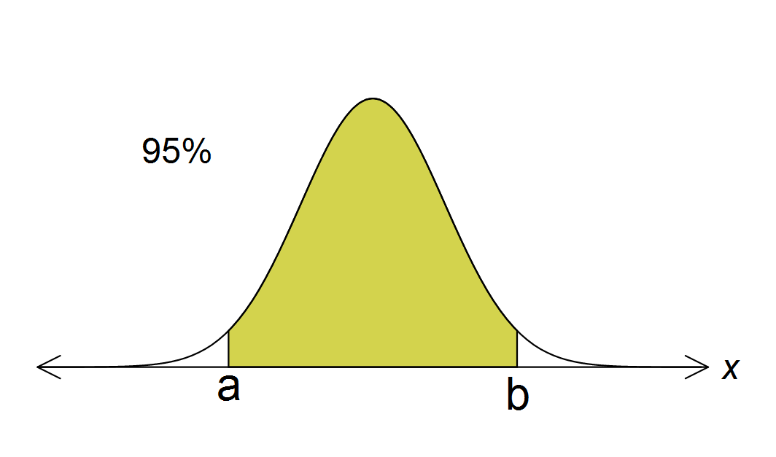

(b) (1 mark)



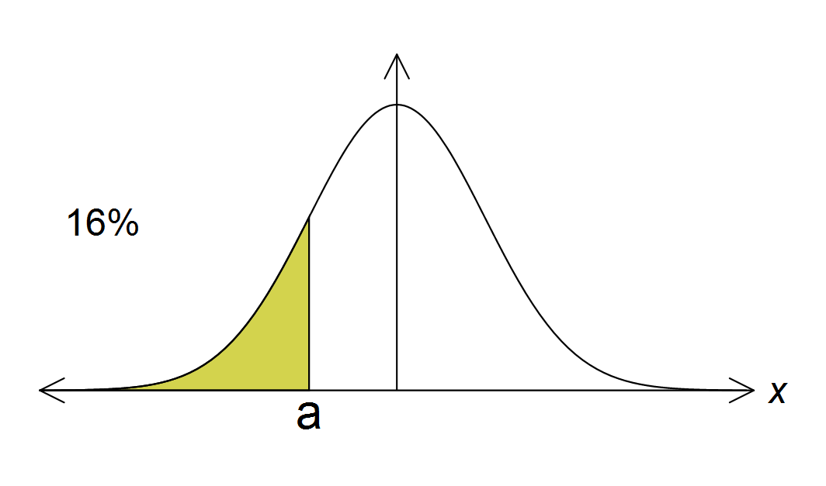

(c) (2 marks)



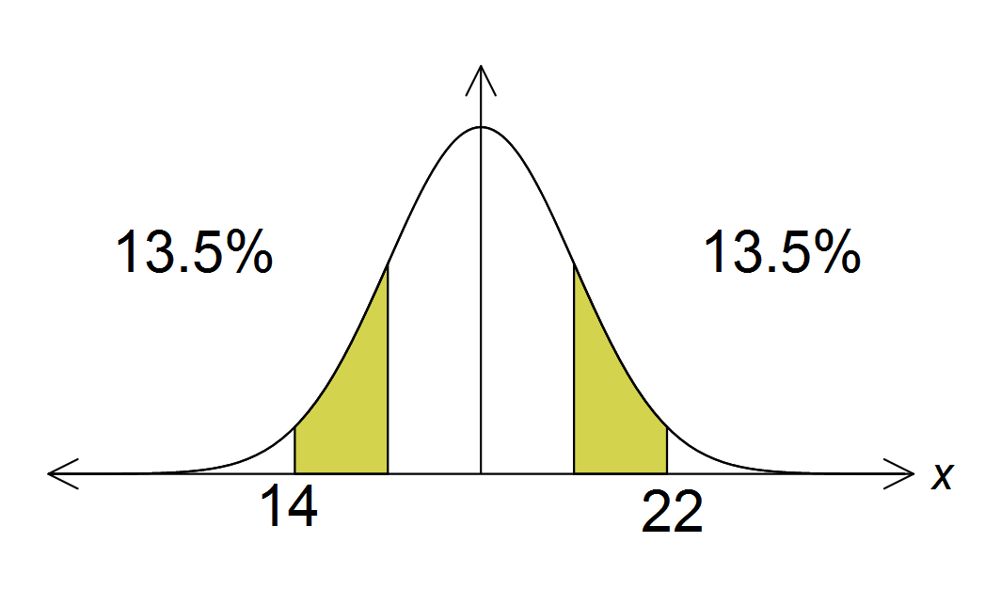

**Question 2 (8 marks)**

The continuous random variable, X, has the probability density function *f*, where



(a) Show that k = 2/3 (4 marks)

(b) Find the expected value of X. (4 marks)

**Question 3 (5 marks)**

Explain why each of the following sampling methods does not represent a random sample.

(a) To predict the outcome of a State Government election, a public opinion poll telephones people randomly selected from a telephone directory to ask which political party they intend voting for on the day of the election. (Give two reasons) (2 marks)

(b) In order to obtain an estimate of the average income of PLC graduates ten years after their graduation all 2006 graduates are to be sent a questionnaire. An estimate of the average income is to be made using the ones that were returned. (1 mark)

(c) At a school assembly the principal of a school with 720 students asks for 20 students to put themselves forward to represent the school at an Anzac Day Dawn Service. (Give two reasons) (2 marks)

**End of Section 1**

**Section 2: Calculator Assumed Name: ________________________**

**Question 4 (7 marks)**

The Yo! Yoghurt Company, a manufacturer of flavoured yoghurts, packages its snack yoghurts in 200 gram containers. The weights of the yoghurts are found to be normally distributed with mean 205 grams and standard deviation 2.55 grams.

(a) What percentage of these yoghurts are underweight? (1 mark)

Management is concerned about the high percentage of yoghurts which are underweight and instructs the production department that only half of one percent of yoghurts leaving the factory may be underweight.

(b) The production department decides to maintain the mean weight of the yoghurts at 205 grams and achieve the management requirement by altering the standard deviation. What must the new standard deviation be set at? (2 marks)

(c) Alternatively, the production sector could achieve the management requirements by maintaining the standard deviation at 2.55 grams and altering the mean weight of yoghurts. What must the new mean weight be set at? (2 marks)

(d) As both methods would achieve the management goal, would it matter which one was adopted? Explain your answer. (2 marks)

**Question 5 (13 marks)**

The lifetimes of Briteglobe light bulbs are normally distributed with mean 3500 hours and standard deviation 200 hours.

(a) What is the probability that the lifetime of a randomly selected bulb is at least 3400 hours?

(1 mark)

(b) Calculate *t*, given that 5% of Briteglobe bulbs last longer than *t* hours. (1 mark)

(c) What is the probability that a Briteglobe bulb lasts exactly 3520 hours? (1 mark)

(d) Calculate the inter-quartile range for this distribution. (2 marks)

***Question 5 continues on next page …***

***Question 5 continued …***

(e) Find the 0.7 quantile and explain what it means. (2 marks)

(f) What is the probability that a Briteglobe bulb will last no more than 3500 hours, if it has already lasted 3200 hours? (3 marks)

(g) Find the probability that in a sample of five Briteglobe bulbs, exactly two will last between 3000 and 3200 hours. (3 marks)

**Question 6 (4 marks)**

The percentage marks of students sitting for a national mathematics competition were found to be normally distributed. The award of Distinction was presented to 15% of the candidates for achieving a mark in excess of 80% and the top 5% of candidates in addition to the Distinction award also received a prize of a gift-voucher for achieving a mark in excess of 90%. Find the mean and standard deviation of the mathematics scores, giving answers to one decimal place.

**Question 7 (8 marks)**

The mean  and standard deviation  of the uniform distribution on the interval [*a*, *b*] are given by

 and  .

A calculator can generate random numbers that are uniformly distributed between 0 and 1.

(a) For this distribution of the random numbers generated by the calculator, calculate

(i) the mean. (1 mark)

(ii) the standard deviation (to **three** **(3)** decimal places). (1 mark)

(b) What is the probability that a randomly generated number lies between  and  ? (1 mark)

(c) What is the probability that a randomly generated number contains no seven in its first **five (5)** digits? (1 mark)

(d) What is the probability that a randomly generated number contains at most three odd digits in its first five digits? Give your answer to **four (4)** decimal places. (2 marks)

(e) Another uniform distribution on an interval [*a*, *b*] has a standard deviation of . How wide is the interval? (2 marks)

**End of Test**